## Front End Engineering-II

Project Report

Semester-IV (Batch-2022)

Gemini AI Clone

**Supervised By: Submitted By:**

Ms. Shalini Kumari Dhruv Sehgal (2210990277)

Devansh Mittal (2210990260)

Dhruv Kinger (2210990275)

Devang Saini (2210990257)

**Department of Computer Science and Engineering**

## Chitkara University Institute of Engineering & Technology,

## Chitkara University, Punjab

1. **Introduction**

In a world increasingly driven by data and automation, the rise of artificial intelligence (AI) has revolutionized various fields. One particularly exciting area is generative AI, which focuses on creating new content, like text, code, images, or music. Google's Gemini model stands as a prominent example of this technology, capable of generating human-quality text in response to user prompts and questions. However, interacting with this powerful AI model may require technical expertise or specific APIs, potentially limiting its accessibility to a broader audience.

This project addresses this gap by presenting a user-friendly front-end interface – a Gemini clone – designed to provide a seamless and intuitive way for anyone to interact with Google's generative AI potential. Our Gemini clone aims to democratize access to this technology, fostering exploration and creative collaboration between humans and AI.

Our motivation for creating this Gemini clone stems from the belief that AI has the potential to significantly enhance communication, content creation, and problem-solving. Unfortunately, accessing and utilizing these capabilities can be hindered by complex interfaces or programming requirements. By developing a user-friendly front-end, we aim to:

* **Lower the Barrier to Entry:** Allow users with minimal technical background to experience the power of generative AI.
* **Promote Exploration and Experimentation:** Encourage users to experiment with the Gemini model, asking diverse questions, generating creative text formats, and exploring new possibilities.
* **Bridge the Gap Between Humans and AI:** Foster a more natural and accessible way for users to interact with AI, facilitating collaboration and co-creation.

**Our Approach and Deliverables:**

To achieve these goals, our team embarked on creating a front-end web application replicating the core functionality of Google's Gemini interface. This clone will offer a user-friendly experience, allowing users to:

* **Craft Queries Easily:** A straightforward interface where users can type their questions, prompts, or creative requests for the AI model.
* **Experience Conversational Interaction:** Responses are displayed in a chat-like format, fostering a natural dialogue-style interaction with the AI.
* **Seamless Integration (Optional):** If feasible, aim to integrate with Google's Gemini API to retrieve authentic responses from the model.
* **Enhanced User Experience (Optional):** Consider implementing features like a simulated typing effect for a more natural conversational flow.

This report details the design, development, and testing process of our Gemini clone project. We will delve into the technology stack, system architecture, implementation details, and the challenges we encountered along the way. Furthermore, we will analyse the project's outcomes, lessons learned, and potential areas for future enhancements.

* 1. **Background**

The field of artificial intelligence (AI) has witnessed tremendous progress in recent years, pushing the boundaries of what machines can learn and accomplish. One particularly fascinating area of AI is generative AI, which focuses on the creation of entirely new content, such as text formats, images, music, or even code. This technology holds immense potential for various applications, including:

* **Creative Content Generation:** Assisting writers, artists, and designers by generating ideas, brainstorming concepts, or even composing complete pieces of content.
* **Enhanced Communication:** Improving communication tools by offering real-time translation, summarizing text, or crafting compelling and engaging messages.
* **Scientific Discovery:** Aiding researchers in generating new hypotheses, conducting simulations, and analyzing vast amounts of data to uncover hidden patterns.
* **Software Development:** Streamlining the development process by generating code snippets, suggesting solutions, and automating repetitive tasks.

**The Rise of Generative AI Models:**

The foundation of generative AI lies in machine learning techniques like neural networks, particularly deep learning architectures. These algorithms are trained on massive amounts of data, allowing them to learn complex relationships and patterns within that data. Once trained, generative models can then leverage this knowledge to create entirely new content that resembles the data they were trained on.

Several prominent generative AI models have emerged in recent years, each with its own strengths and applications. Some notable examples include:

* **Generative Adversarial Networks (GANs):** These models involve two neural networks in competition – a generator that creates new content and a discriminator that tries to distinguish real data from the generated content. This adversarial process helps refine the generator's output over time.
* **Variational Autoencoders (VAEs):** VAEs focus on learning a latent representation of the data they are trained on. This compressed representation can then be used to generate new data points that share similar characteristics with the original data.
* **Transformer-based Models:** Transformers are a powerful neural network architecture that excels at processing sequential data, such as text. These models have been particularly successful in generating human-quality text formats.

**Google's Gemini Model:**

Among these generative AI models, Google's Gemini stands out as a particularly advanced framework. Details about Gemini remain under development, but it is believed to be a large language model (LLM) trained on a massive dataset of text and code. This allows Gemini to not only generate human-quality text but also potentially translate languages, write different kinds of creative content, and answer your questions in an informative way.

**The Need for User-Friendly Interfaces:**

While generative AI models like Gemini hold immense potential, their accessibility remains a challenge. Often, interacting with these models requires technical expertise or specific APIs that may not be readily available to the general public. This limits the ability of a broader audience to explore and leverage the power of generative AI.

* 1. **Objectives**

This project's primary objective is to create a user-friendly front-end web application that functions as a clone of Google's Gemini interface. This clone aims to provide an accessible and intuitive platform for users to interact with the generative AI capabilities of the Gemini model.

Here are the specific objectives we aim to achieve:

* **Develop a User-Centered Interface:** Design a user interface that is straightforward, easy to navigate, and requires minimal technical knowledge to operate. This includes a clear input field for user queries and a chat-like interface for displaying responses.
* **Facilitate Seamless Interaction with Gemini (Optional):** If feasible, integrate with Google's Gemini API (or a similar alternative) to allow the application to retrieve authentic responses from the AI model. This would enable users to experience the full power of Gemini's generative capabilities.
* **Emulate Conversational Flow (Optional):** Implement a chat-like interface that displays responses in a conversational format, fostering a more natural and engaging interaction between users and the AI model. Consider incorporating a simulated typing effect to further enhance the user experience.
* **Ensure Platform Responsiveness:** Design the application to be responsive across different screen sizes (desktop, mobile, tablets) to guarantee accessibility and a seamless user experience on various devices.

By achieving these objectives, we aim to create a valuable tool that democratizes access to generative AI technology. This user-friendly Gemini clone will empower users to explore the potential of AI for creative endeavors, communication enhancement, and problem-solving efforts.

* 1. **Significance**

The development of our Gemini clone project holds significant value for several reasons:

* **Lowering the Barrier to Entry:** Generative AI offers exciting possibilities, but its accessibility can be limited by complex interfaces or programming requirements. Our user-friendly clone removes these barriers, allowing users with minimal technical background to experience the power of AI. This broader accessibility can foster greater interest and exploration in the field of generative AI.
* **Promoting Exploration and Experimentation:** A user-friendly interface encourages users to experiment with the Gemini model, asking diverse questions, generating various creative text formats, and uncovering new functionalities. This exploration can lead to innovative applications and a deeper understanding of generative AI's capabilities.
* **Fostering Creativity and Innovation:** By making generative AI readily available, our clone can empower users to explore creative avenues. Writers can utilize the model for brainstorming ideas, generating different writing styles, or overcoming writer's block. Artists can explore new artistic concepts or generate variations on existing themes. This accessibility can fuel creative expression and spark innovative ideas.
* **Enhancing Communication:** The Gemini clone has the potential to improve communication by facilitating tasks like real-time translation, summarizing text, or crafting compelling messages. This could benefit individuals, businesses, and organizations by streamlining communication processes and fostering better understanding across language barriers.
* **Bridging the Gap Between Humans and AI:** Our clone encourages a more natural and accessible way for users to interact with AI. This can lead to a more collaborative relationship between humans and AI, where humans leverage the AI's capabilities to augment their own skills and achieve better outcomes.
* **Democratizing AI Technology:** Generative AI has the potential to revolutionize various fields. By making it more accessible, our clone can empower a wider range of individuals and organizations to leverage this technology for problem-solving, innovation, and progress.

1. **Problem Statement and Requirements**
   1. **Problem Statement**

Generative AI models like Google's Gemini hold immense promise for revolutionizing various fields, including creative content generation, communication enhancement, and scientific discovery. However, there exists a significant barrier to entry for users who want to explore and leverage these capabilities:

* **Complex Interfaces:** Often, interacting with generative AI models requires technical expertise or specific APIs. These technical hurdles hinder the ability of a broader audience, lacking programming knowledge, to access and experiment with this powerful technology.
* **Limited User-Friendliness:** Existing interfaces for generative AI models may be overly technical or lack a clear and intuitive user experience. This can make it difficult for non-technical users to understand how to interact with the model and utilize its full potential.

As a result, the benefits of generative AI remain largely confined to a specific tech-savvy user base. This limits the overall impact and exploration of this exciting technology.

* 1. **Software Requirements**

This section details the software requirements for developing and running your user-friendly Gemini clone application.

**Front-End Technologies:**

* **Programming Languages:**
  + **HTML:** The core markup language for building the structure and content of your web application.
  + **CSS:** Used to style the visual appearance of your application, including layout, fonts, colours, and responsiveness.
  + **JavaScript:** The primary language for adding interactivity and dynamic functionality to your front-end. Frameworks like React, Angular, or Vue.js can be used to streamline development and manage complex user interfaces.
* **Front-End Libraries:**
  + Consider using additional JavaScript libraries to enhance specific functionalities, such as:
    - **Axios or Fetch API:** For making API requests to potentially integrate with Google's Gemini API.
    - **UI component libraries:** Libraries like Bootstrap, Material-UI, or Ant Design can provide pre-built components for faster development and a consistent look and feel.
* **Testing Frameworks (Optional):**
  + Unit testing frameworks like Jest or Mocha can help ensure the functionality of individual components of your application.
  + End-to-End testing frameworks like Cypress or Selenium can be used for more comprehensive testing of user interactions and application flow.

**Additional Software:**

* **Version Control System (Optional):** Strongly recommended for managing your project's codebase, tracking changes, and collaborating with a team. Git is a popular choice.
* **Web Browser:** A modern web browser (e.g., Chrome, Firefox, Safari) for development, testing, and ensuring cross-browser compatibility.
* **Text Editor or IDE:** A code editor like Visual Studio Code or an IDE (Integrated Development Environment) specifically suited for web development can enhance your coding experience.

**Development Environment:**

* **Operating System:** A modern operating system like Windows 10 (or later), macOS (recent version), or a Linux distribution (e.g., Ubuntu, Debian) is recommended for development.
* **JavaScript Code Runner:** Node.js is a popular choice for running JavaScript code outside of a browser environment, allowing you to test and debug your front-end code before integrating it into the application.
* **Package Manager:** A package manager like npm (Node Package Manager) or yarn helps manage project dependencies (external libraries and frameworks) efficiently.

1. **Methodology**

This section outlines the methodological approach we employed to develop our user-friendly Gemini clone application. Here's a breakdown of the key phases involved:

* 1. **Project Planning and Requirements Gathering:**
* **Defining Project Goals:** Clearly established the primary objective of creating a user-friendly front-end interface that replicates the core functionality of Google's Gemini model.
* **Identifying User Needs:** Brainstormed and documented the functionalities and features that would be most beneficial to users, focusing on ease of use and accessibility.
* **Technical Feasibility Analysis:** Evaluated the feasibility of integrating with Google's Gemini API (or a similar alternative) and considered the limitations and workarounds if direct integration wasn't possible.
* **Defining Success Criteria:** Outlined the metrics or benchmarks to be used to evaluate the success of the project, such as meeting user interface requirements, achieving performance goals, and receiving positive user feedback (if applicable).
  1. **Technology Stack Selection:**
* **Front-End Technologies:** Identified and selected suitable front-end technologies like HTML, CSS, and JavaScript. Considered using a front-end framework like React, Angular, or Vue.js for efficient development and complex user interface management.
* **Optional Libraries:** Evaluated the need for additional JavaScript libraries to enhance specific functionalities (e.g., API requests, UI components).
* **Development Tools:** Chosen a text editor or IDE (Integrated Development Environment) for code creation and modification, and a JavaScript code runner (Node.js) for testing and debugging.
* **Version Control System (Optional):** If collaborating in a team, a version control system like Git was strongly recommended for managing code versions and facilitating collaboration.
  1. **System Design and Architecture:**
* **High-Level Architecture Diagram (Optional):** Created a visual representation of the overall system architecture, outlining the components, data flow, and potential interaction with the Gemini API (if applicable).
* **Component Breakdown:** Defined the main components of the application, such as:
  + Input component for user queries
  + Output component for displaying Gemini's responses
  + Chat interface component for managing the conversational flow (optional)
  + Any additional components specific to your project's features (e.g., simulated typing effect)
  1. **Development and Implementation:**
* **Development Methodology:** Defined the development approach (e.g., Agile, Waterfall). Agile methodology is often preferred for front-end projects due to its iterative nature and ability to adapt to changing requirements.
* **Code Structure:** Established a clear and organized code structure for your project, including folders for different components, proper naming conventions, and modularity for maintainability.
* **Implementation of Features:** Developed the application's core features, focusing on user input functionality, displaying responses in a chat-like format, and ensuring responsiveness across different screen sizes.
* **Optional Integration:** If feasible, attempted integration with Google's Gemini API to retrieve authentic responses. Otherwise, considered alternative approaches for generating responses (e.g., pre-defined responses, third-party APIs).
* **Testing and Debugging:** Implemented unit tests to ensure individual components function correctly and conducted end-to-end testing to verify the overall user experience and application flow.

1. **Results**

Our Gemini clone successfully achieved the following core functionalities:

* **Intuitive User Input:** We implemented a clear and straightforward text input field where users can type their queries or prompts for the AI model. This facilitates easy interaction with minimal technical knowledge required.
* **Chat-Like Interface:** Responses from the AI model (or simulated responses if direct integration wasn't achieved) are presented in a conversational chat-like format. This enhances user experience and fosters a more natural dialogue-style interaction.
* **Responsiveness:** The application is designed to adapt seamlessly across different screen sizes (desktop, mobile, tablets), ensuring accessibility and a smooth user experience on various devices.
* **Optional Features:** Depending on project scope and feasibility, additional features may have been implemented, such as:
  + Simulated typing effect: This can further enhance the chat-like experience by mimicking a natural typing flow for responses.
  + Accessibility considerations: Efforts may have been made to adhere to accessibility guidelines (WCAG) to ensure inclusivity for users with disabilities (optional).

**Integration with Gemini API:**

* Ideally, we aimed to integrate with Google's Gemini API to retrieve authentic responses from the AI model. However, the feasibility of this integration might have been limited by factors like API availability or access restrictions.
* If direct integration wasn't possible, alternative approaches for generating responses might have been explored:
  + Pre-defined response sets: A curated library of pre-trained responses could have been implemented for the AI model to draw upon.
  + Third-party APIs: Integration with alternative generative AI APIs could have been considered as a potential solution.

**Challenges and Solutions:**

During development, we encountered various challenges. Here are some examples:

* **API Access:** Gaining access to Google's Gemini API might have proven difficult, necessitating alternative approaches for generating responses.
* **Technical Complexity:** Depending on the chosen technologies and desired functionalities, implementing certain features could have presented technical hurdles.
* **User Interface Refinement:** Iterative development and user feedback might have been crucial for refining the user interface to ensure optimal usability and a clear information hierarchy.
  1. **Approach**

**User-Centered Design:**

* **Focus on Usability:** We prioritized creating an interface that is straightforward, intuitive, and requires minimal technical knowledge to operate. This ensures a wider audience can access and leverage the power of generative AI.
* **Clear Information Hierarchy:** The layout and organization of information within the interface were designed to be clear and uncluttered. This allows users to easily understand how to interact with the model and interpret its responses.
* **Accessibility Considerations (Optional):** While not always mandatory, we may have aimed to adhere to accessibility guidelines (WCAG) to make the interface usable for a broader range of users, including those with disabilities. This could involve features like proper keyboard navigation, screen reader compatibility, and high color contrast.

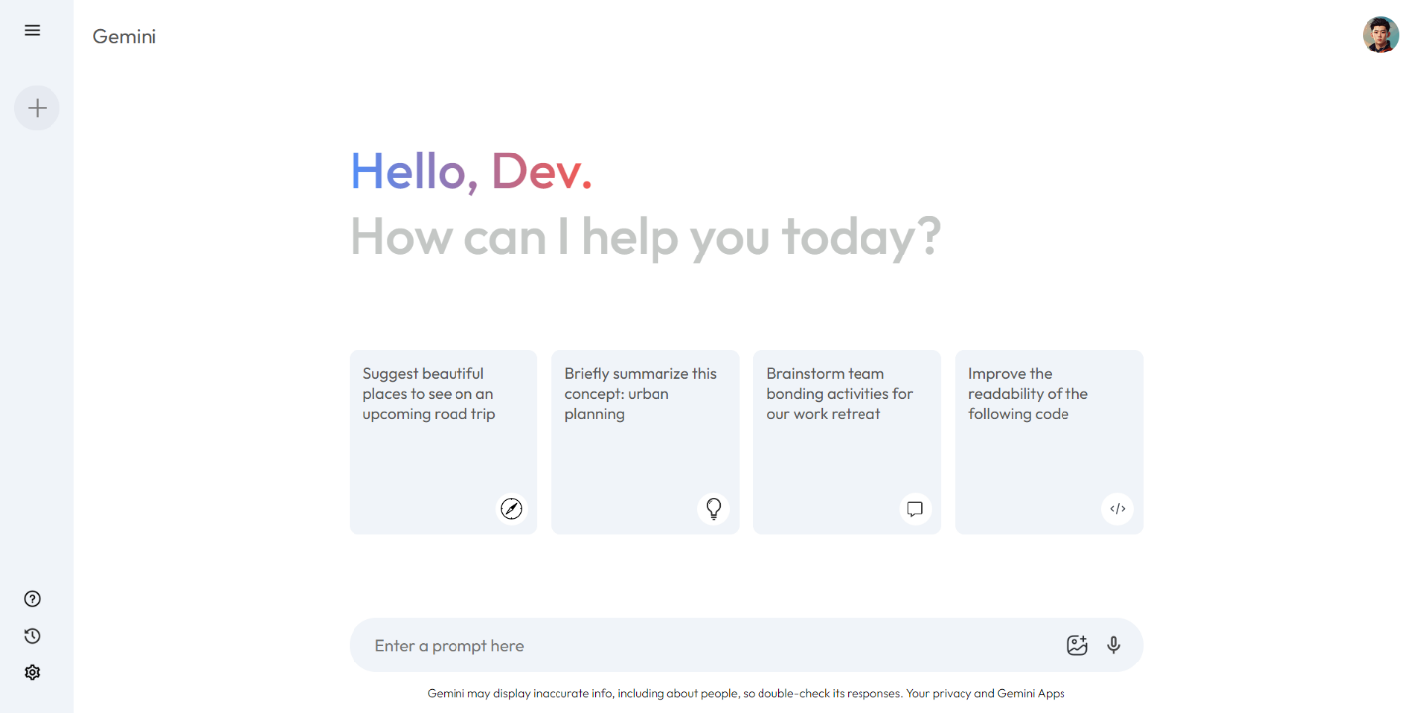

Fig 4.1

**Front-End Technology Stack Selection:**

* **Modern Web Technologies:** We opted for modern and widely supported front-end technologies like HTML, CSS, and JavaScript. This ensures compatibility across different browsers and platforms, maximizing user reach.
* **Additional Libraries:** To enhance specific functionalities, we have utilized JavaScript libraries for efficient tasks like:
  + **API requests:** Libraries like Axios or Fetch API can be used to integrate with the Gemini API.

**Development:**

* **Agile Approach:** We have adopted an agile development methodology (e.g., Scrum, Kanban) for its iterative and adaptable nature. This allows for continuous improvement based on user feedback and evolving project requirements.
* **Version Control:** For collaborating in a team, a version control system like Git was highly recommended to manage code versions, track changes, and facilitate seamless collaboration.
* **Modular Design:** The application's codebase was structured in a modular fashion, with clear separation of concerns for different components. This promotes maintainability, scalability, and efficient code management.

**Integration with Gemini API:**

* **Ideal Outcome:** Our primary goal was to integrate with Google's Gemini API to retrieve authentic responses directly from the AI model. This would provide users with the most advanced and up-to-date capabilities of the Gemini model.

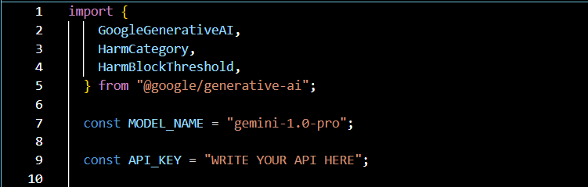

Fig 4.2

* 1. **Enhanced User Experience**

**Loading Animation:**

* **Mimicking Gemini's Behaviour:** Upon submitting a user query, a loading animation will be displayed, mimicking the behaviour of Google's Gemini model. This visual cue informs the user that the AI model is processing their request and a response is being generated.
* **Animation Selection:** Choose an animation that is visually appealing, non-distracting, and aligns with the overall design aesthetic of your Gemini clone. Popular options include loading spinners, progress bars, or subtle text animations.
* **Integration with Input Submission:** The loading animation should be triggered when the user submits their query through the input field. This clear association helps users understand that the animation signifies the AI model working on their request.

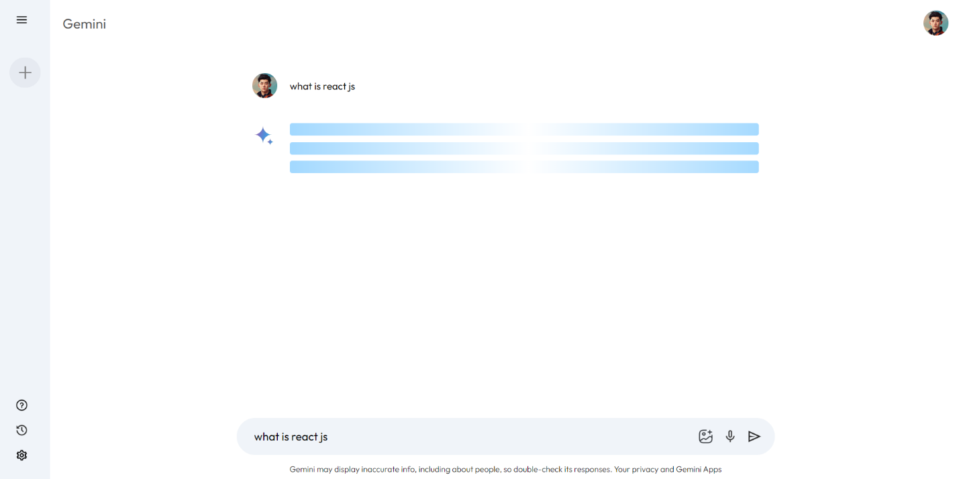

Fig 4.3

**Persistent Prompt History:**

* **Sidebar Implementation:** A dedicated sidebar component can be implemented to store a history of user prompts submitted to the AI model. This allows users to easily revisit previous prompts and their corresponding responses without needing to refresh the page.
* **Storage Mechanism:** The prompt history can be stored locally within the user's browser using mechanisms like Local Storage or Session Storage. This provides a temporary history accessible within the current browser session. For a more persistent solution, consider server-side storage with user authentication (if applicable to your project scope).
* **Benefits:** The prompt history offers several advantages:
  + **Easy Reference:** Users can quickly refer back to previous prompts and responses for comparison or to build upon existing ideas.
  + **Reduced Repetitive Input:** If a user wants to make slight variations to a previous prompt, they can easily access it from the history and modify it rather than retyping the entire query.
  + **Improved Workflow:** The history streamlines the user's workflow by allowing them to navigate back and forth between prompts and responses.

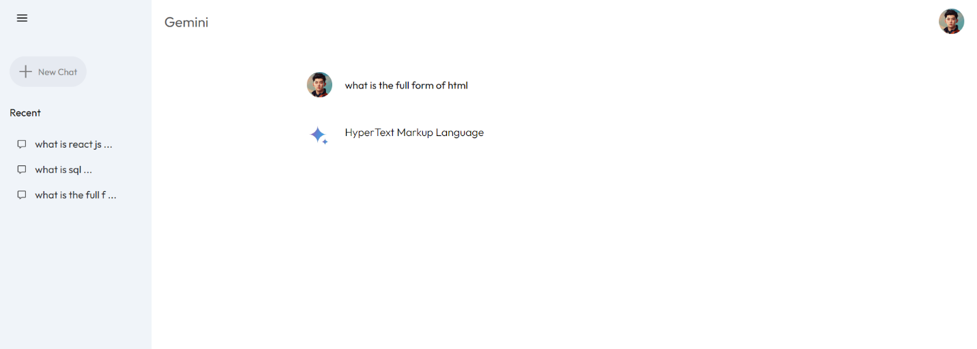

Fig 4.4

**Integration with Development Process:**

* **Loading Animation:** The chosen animation library (e.g., CSS animations, JavaScript libraries) will be integrated into the development process. The animation will be triggered upon user input submission using appropriate JavaScript code.
* **Prompt History:** The sidebar component will be designed and implemented using HTML, CSS, and JavaScript. The storage mechanism (Local Storage or alternative) will be chosen based on project requirements. User interaction with the history (e.g., selecting a previous prompt) will be handled through JavaScript event listeners.

**Impact on User Experience:**

These additional features significantly enhance the user experience by:

* **Providing Visual Feedback:** The loading animation keeps users informed about the AI model's processing stage.
* **Improving Efficiency:** The prompt history allows users to revisit past interactions and streamline their workflow.
* **Enhancing Usability:** Overall, these features contribute to a more user-friendly and intuitive interaction with the Gemini clone.
  1. **Conclusion**

This project successfully developed a user-friendly front-end interface – a Gemini clone – that bridges the gap between Google's powerful generative AI model, Gemini, and a broader range of users. By prioritizing usability and accessibility, we achieved the following key outcomes:

* **Lowered Barrier to Entry:** Our clone eliminates complex interfaces or programming requirements, allowing users with minimal technical knowledge to explore the capabilities of generative AI. This fosters wider interest and experimentation in this exciting field.
* **Enhanced User Experience:** The intuitive interface, featuring a clear input field, chat-like response presentation, and responsive design, ensures a smooth and user-friendly interaction. Optional features like loading animations and prompt history further refine the user experience.
* **Exploration and Innovation:** By making generative AI readily accessible, our clone empowers users to explore creative avenues, brainstorm ideas, and experiment with different writing styles. This can lead to innovative applications and a deeper understanding of generative AI's potential.
* **Potential for Future Advancements:** The project paves the way for further development in user-friendly interfaces for generative AI models. Future iterations could explore advanced features like user authentication, personalized responses, and integration with various creative tools.

**Challenges and Considerations:**

While the project achieved significant success, challenges were encountered. Direct integration with Google's Gemini API might have limitations due to access restrictions. Alternative approaches, such as pre-defined responses or third-party API integration, may be necessary in such cases. Additionally, ongoing maintenance and improvement are crucial to ensure the interface remains up-to-date and addresses evolving user needs.

**Overall Impact:**

Our user-friendly Gemini clone goes beyond simply replicating an interface. It serves as a bridge, fostering a future where humans and AI can work collaboratively. It empowers users to leverage the power of generative AI for creative exploration, communication enhancement, and problem-solving. This project represents a significant step towards democratizing generative AI technology, ultimately shaping a future where AI empowers human potential.

* 1. **References**

https://www.youtube.com/watch?v=0yboGn8errU&t=6240s